Game Document Usage Instructions
Math Documents : H022191R.xlsx, H022193R.xlsx

Worksheet Function Introduction
Overview: Provides the game value settings
- Coin (Base Bet)
- Total Pay Back (Total RTP)
- Hit JP Symbol appear rate: The appearance rate of the Scatter symbol
- Window Size
- Free Game round settings
- Paytable

Parameter: Provides all parameters used in the game
- Parameter
  - BaseGame
    - After each spin in the Base Game, this weight determines which BaseGameSymbol is used.
  - FreeGame
    - After each spin in the Free Game, this weight determines which FreeGameSymbol is used.
  - BaseDrop
    - After symbols are eliminated in the Base Game, the weight corresponding to the elimination count determines which BaseGameSymbolDrop is used.
  - FreeDrop
    - After symbols are eliminated in the Free Game, the weight corresponding to the elimination count determines which FreeGameSymbolDrop is used.
  - Base Eliminate
    - When no elimination occurs in the Base Game, the elimination count and Trigger/(Trigger + No Trigger) are used to determine whether the Mega Symbol feature is triggered.
    - When the Mega Symbol feature is triggered, a 2×2 large symbol is overlaid onto the board.
    - If symbols below the 2×2 large symbol are eliminated, the large symbol remains in place, and symbols above it drop past the large symbol to the space below it.
  - Base Eliminate Times
    - The weight determines how many 2×2 large symbols are overlaid onto the board.
    - Placement rules for 2×2 large symbols:
      - The FIRST 2×2 large symbol must be adjacent to at least one matching symbol on the board.
        - Adjacent definition: the 8 surrounding positions around the 2×2 area (top-left, top-center, top-right, middle-left, middle-right, bottom-left, bottom-center, bottom-right).
        - The symbol type of the 2×2 block must match at least one symbol in these 8 adjacent positions.
      - The SECOND and subsequent 2×2 large symbols do NOT require adjacency checking.
      - All large symbols cannot cover C1 symbols.
      - All large symbols cannot overlap each other.
    - Placement attempt limit:
      - The system attempts up to 100 times to find a valid position for each large symbol.
      - If no valid position is found after 100 attempts, that particular large symbol is not placed.
      - Successfully placed large symbols remain on the board.
      - Failed placements do not affect game continuation or previously placed symbols.
  - Base Eliminate Symbol
    - The weight determines which symbol type the 2×2 large symbol is converted into.
  - Free Eliminate
    - When no elimination occurs in the Free Game, the elimination count and Trigger/(Trigger + No Trigger) are used to determine whether the Mega Symbol feature is triggered.
    - When the Mega Symbol feature is triggered, a 2×2 large symbol is overlaid onto the board.
    - If symbols below the 2×2 large symbol are eliminated, the large symbol remains in place, and symbols above it drop past the large symbol to the space below it.
  - Free Eliminate Times
    - The weight determines how many 2×2 large symbols are overlaid onto the board.
    - Placement rules for 2×2 large symbols:
      - The FIRST 2×2 large symbol must be adjacent to at least one matching symbol on the board.
        - Adjacent definition: the 8 surrounding positions around the 2×2 area (top-left, top-center, top-right, middle-left, middle-right, bottom-left, bottom-center, bottom-right).
        - The symbol type of the 2×2 block must match at least one symbol in these 8 adjacent positions.
      - The SECOND and subsequent 2×2 large symbols do NOT require adjacency checking.
      - All large symbols cannot cover C1 symbols.
      - All large symbols cannot overlap each other.
    - Placement attempt limit:
      - The system attempts up to 100 times to find a valid position for each large symbol.
      - If no valid position is found after 100 attempts, that particular large symbol is not placed.
      - Successfully placed large symbols remain on the board.
      - Failed placements do not affect game continuation or previously placed symbols.
  - Free Eliminate Symbol
    - The weight determines which symbol type the 2×2 large symbol is converted into.
- BaseGameSymbol
  - Symbol: Base Game reel strip (1-5)
    - The stop position is selected according to the weights.
    - MY1–MY3 symbols are uniformly converted into the same symbol according to MY Weight.
- BaseGameSymbolDrop
  - Symbol: Base Game drop table (1-6)
  - Extraction method: Each time symbols are replenished, the extraction method determines whether the Random method or the Parallel method is used.
  - Random Weights: When using the Random method, the starting positions for replenishment symbols on R1–R7 are selected according to Random Weights.
  - Parallel Weights: When using the Parallel method, the starting position for replenishment symbols is selected according to Parallel Weights, and R1–R7 use the same position.
  - MY Weight: MY1–MY3 symbols are uniformly converted into the same symbol according to MY Weight, At most one C1 can appear in the same row. If a C1 already exists, the dropped C1 is converted to MY1.
- FreeGameSymbol
  - Symbol: Free Game reel strip (1-5)
  - The stop position is selected according to the weights.
  - MY1–MY3 symbols are uniformly converted into the same symbol according to MY Weight.
- FreeGameSymbolDrop
  - Symbol: Free Game drop table (1-6)
  - Extraction method: Each time symbols are replenished, the extraction method determines whether the Random method or the Parallel method is used.
  - Random Weights: When using the Random method, the starting positions for replenishment symbols on R1–R7 are selected according to Random Weights.
  - Parallel Weights: When using the Parallel method, the starting position for replenishment symbols is selected according to Parallel Weights, and R1–R7 use the same position.
  - MY Weight: MY1–MY3 symbols are uniformly converted into the same symbol according to MY Weight.

Game Flow
Jackpot System Reference: Math Document Description_JP
Score Limit (Base Game):
If the total non-Jackpot win of a single round—the Base Game spin plus any Free Game it triggers—exceeds 5,000 times the bet, the entire round is discarded and re-drawn (re-played from the beginning) until the total non-Jackpot win does not exceed 5,000 times the bet.
Any Jackpot win awarded during the round is excluded from the 5,000-times-bet limit..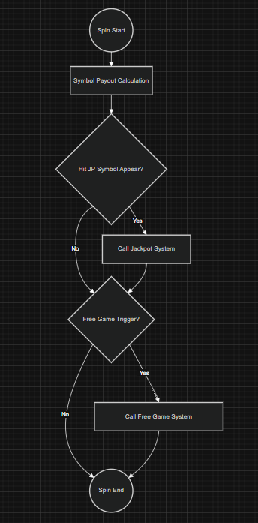

Free Game System:
Score Limit (Free Game):
The non-Jackpot win accumulated during the Free Game is included in the single-round total win. If the total non-Jackpot win of the round—the Base Game plus the Free Game—exceeds 5,000 times the bet, the entire round is discarded and re-drawn from the beginning until the total non-Jackpot win does not exceed 5,000 times the bet.
Any Jackpot win awarded during the Base Game or Free Game is excluded from the 5,000-times-bet limit.

